DAY 11 REPORT
Home Task – Graph Plotting using Matplotlib
Introduction
Matplotlib is a Python library used for creating graphs and data visualizations. It helps to represent numerical data in graphical format for analysis and better understanding. Matplotlib is widely used in Data Analysis, Machine Learning, and Data Science projects.

Import Statement
import matplotlib.pyplot as plt
- matplotlib → Main visualization library
- pyplot → Module used for graph plotting
- plt → Alias name used for easy access

Home Task
Creation of 2 Random Variables and Different Graphs
Different graph plotting techniques were implemented using Matplotlib in Google Colab.

1. Line Graph
Program
import matplotlib.pyplot as plt
x = [1,2,3,4,5]
y = [10,20,30,40,50]
plt.plot(x,y)
plt.xlabel("X Values")
plt.ylabel("Y Values")
plt.title("Line Graph")
plt.show()
Graph:
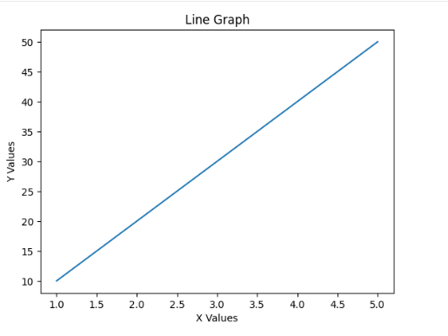
Functions Used
- plt.plot() → Creates line graph
- plt.xlabel() → Adds x-axis label
- plt.ylabel() → Adds y-axis label
- plt.title() → Adds graph title
- plt.show() → Displays graph

2. Bar Graph
Program
import matplotlib.pyplot as plt
x = ["A","B","C","D"]
y = [20,40,60,80]
plt.bar(x,y)
plt.xlabel("Categories")
plt.ylabel("Values")
plt.title("Bar Graph")
plt.show()
Graph:
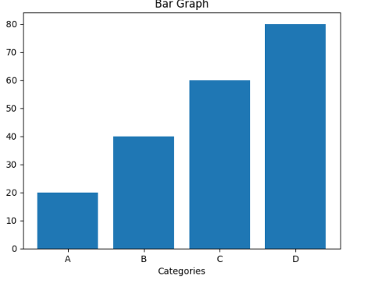
Functions Used
- plt.bar() → Creates bar graph
- plt.xlabel() → Adds x-axis label
- plt.ylabel() → Adds y-axis label
- plt.title() → Adds graph title
- plt.show() → Displays graph

3. Scatter Plot
Program
import matplotlib.pyplot as plt
x = [10,20,30,40,50]
y = [15,25,35,45,55]
plt.scatter(x,y)
plt.xlabel("X Values")
plt.ylabel("Y Values")
plt.title("Scatter Plot")
plt.show()
Graph:
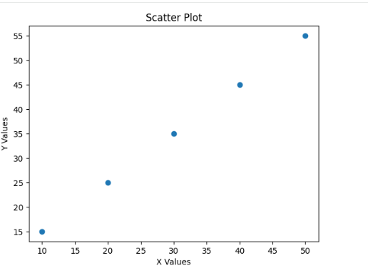
Functions Used
- plt.scatter() → Creates scatter plot
- plt.xlabel() → Adds x-axis label
- plt.ylabel() → Adds y-axis label
- plt.title() → Adds graph title
- plt.show() → Displays graph

4. Pie Chart
Program
import matplotlib.pyplot as plt
values = [20,30,25,25]
labels = ["A","B","C","D"]
plt.pie(values, labels=labels)
plt.title("Pie Chart")
plt.show()
Graph:
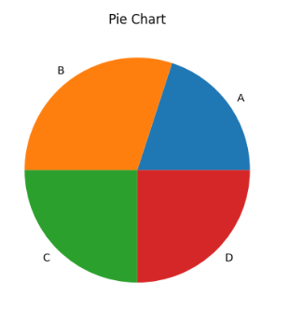
Functions Used
- plt.pie() → Creates pie chart
- plt.title() → Adds graph title
- plt.show() → Displays graph

Conclusion
On Day 11, different graph plotting techniques were practiced using Matplotlib in Google Colab. Various graphs such as line graphs, bar graphs, scatter plots, histograms, and pie charts were created for data visualization. The session helped in understanding graphical representation and visualization of data using Matplotlib.

